**2. Description of data and GIS processes (250 - 500 words, 2-3 tables, 2-4 figures)**. Here you will describe your data, including the source and origin, as well as a plan for what GIS operations you will be conducting during your project.

My goal is to identify education deserts at the census tract level and identifying deserts based on distance but also household income. Before in my blog I mentioned bringing in all sorts of data cost of transportation, types of jobs, ethnicity etc. After speaking with Dr. Sparks for the sake of time I will focus on income levels. I have found the ACS has median household income at the tract level.

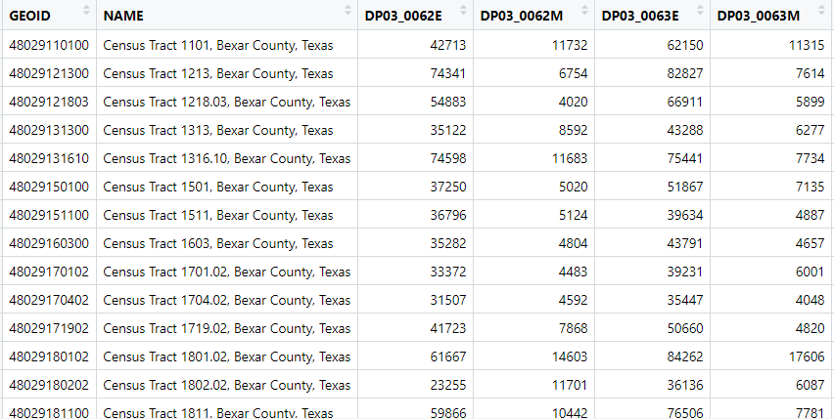

Here is looking at the Mean and Median values in San Antonio.

I was having trouble with get_acs function to grab all the tracts in the United States but it is a continuing process learning how to best work with census data.

My school data is from the Integrated Postsecondary Education Data System (IPEDS). Using one of their data products I was able to grab all the postsecondary schools in the United States. These include schools that offer GED, medical schools, law schools. I plan to filter out these schools and focus on degree awarding bachelors schools. Education deserts are defined with a board access schools nearby. Board access meaning the selectivity is very low with admitting 75 % of students. I will filter for these schools. Lucky for me the IPEDS data also has longitude and latitude data to help merge with census tract infomation.

Once I have filtered the schools and got the census data I will use a 60 mile buffer around the census tracts to match school data to tracts. Once the data is spatially merged then I can count how many schools are in the radius and compare the median household income and price of the school. The IPEDS data also has school price based off the income level as well for example average price for 10,000 – 20,000 income students. I want to see if I can match those average prices with the tracts.

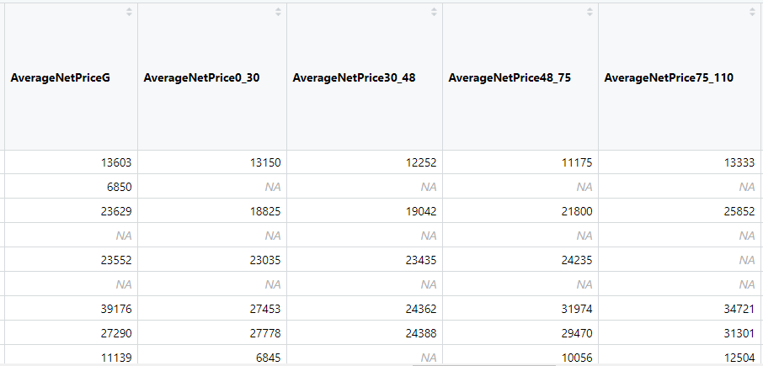

Here you can see the Average Net price depending on income level variables.

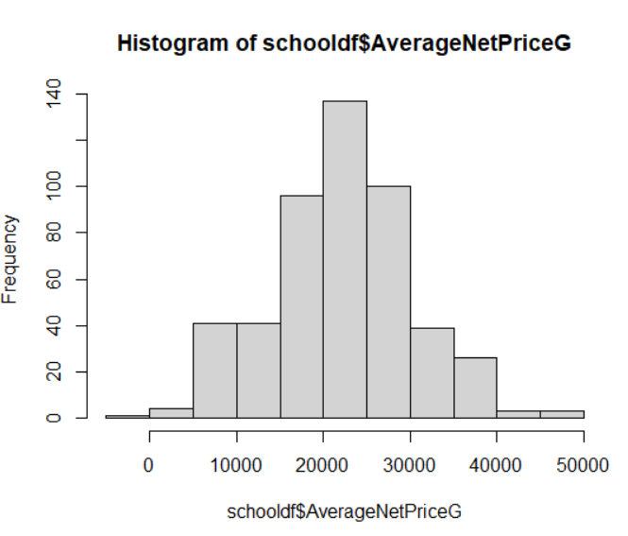

Here we can see that Average Net Price in general follows close to a bell curve

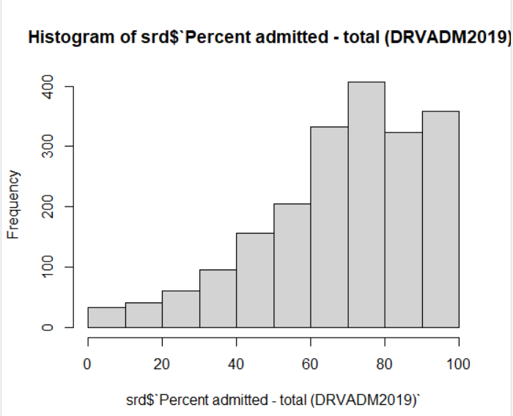

We can see here the histogram of all the schools in the united states percent admitted.